Test security of UPI application on desktop sharing applications.
Here is the list of UPI applications
PhonePe
GPay
Paytm
Etc
Here is the list of Desktop Sharing applications
TeamViewer
AnyDesk
Step1: Download and Install AnyDesk in windows
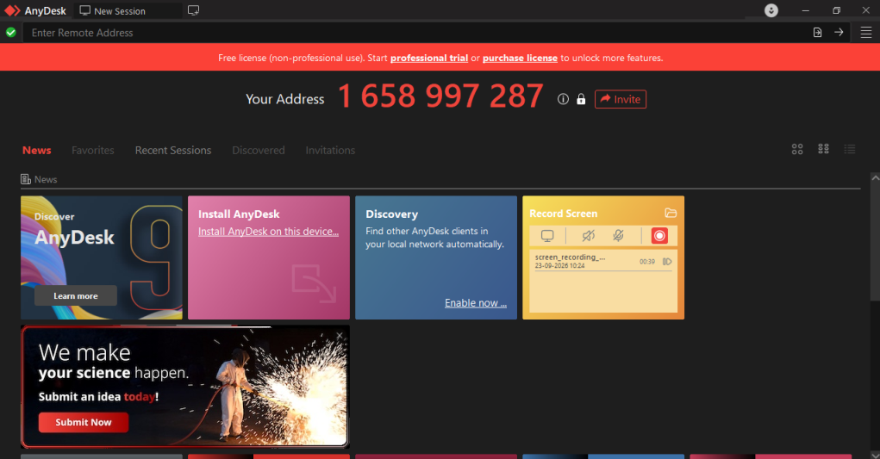
Step2: Download and install AnyDesk in Mobile
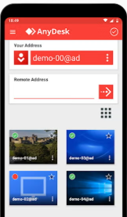

Step 3: Connect mobile AnyDesk with Windows AnyDesk application
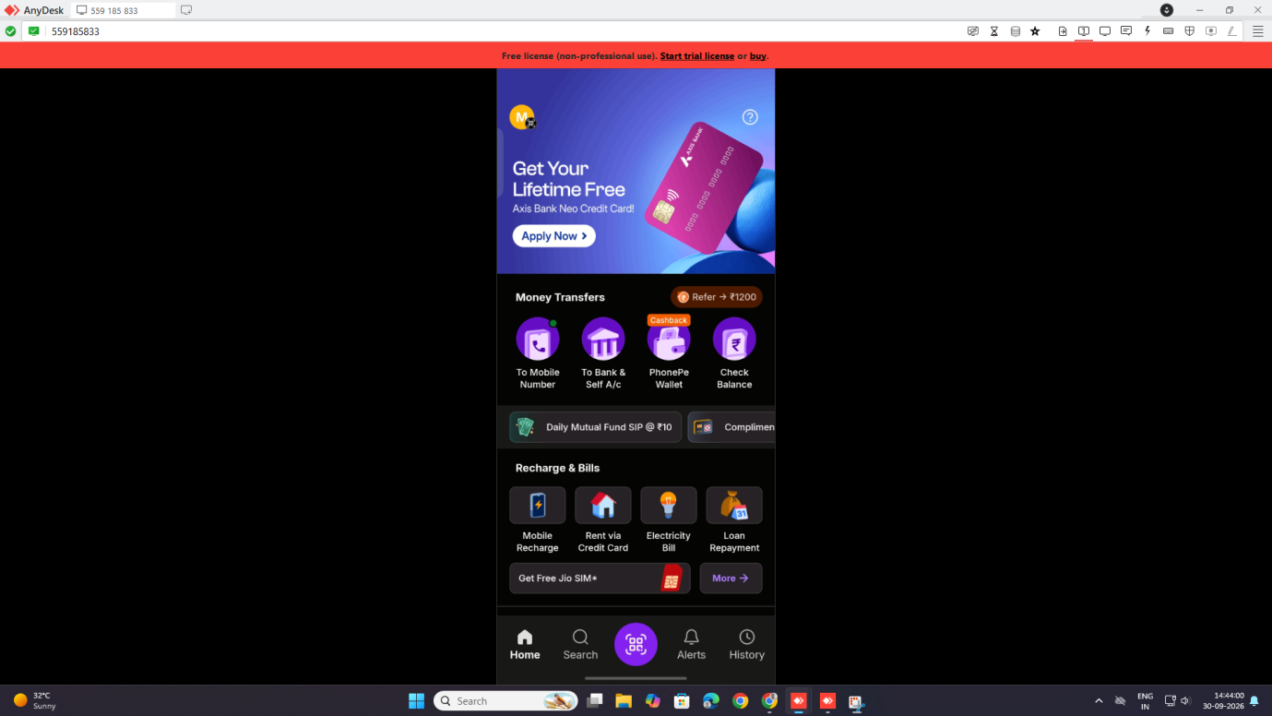
Step 4: Now open any UPI application and perform any transactions.
Step 5: The respective UPI application should show the below message.
